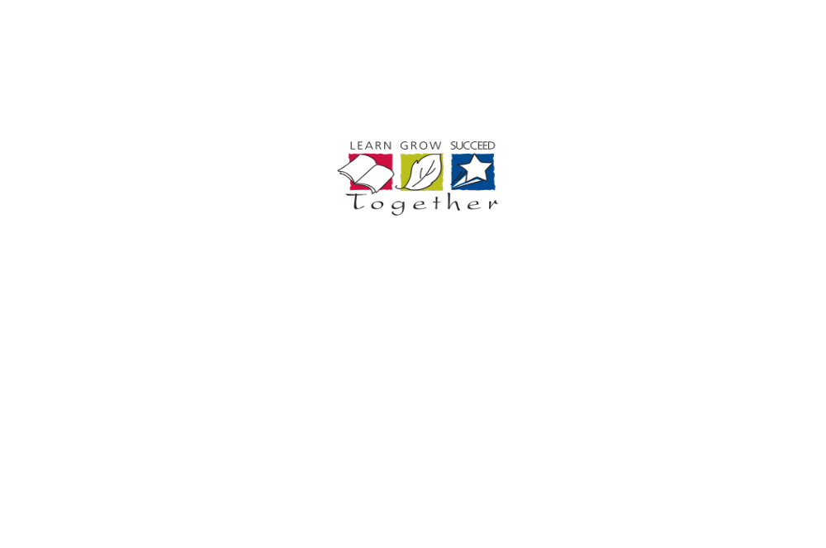
Lester B. Pearson High School

English ENG 2D1
Grade 10 Academic
Ms. K. Compton-Morgan comptonmorgank@hdsb.ca

This course is designed to extend the range of oral communication, reading, writing, and media literacy skills that students need for success in their secondary school academic programs and in their daily lives. Students will analyse literary texts from contemporary and historical periods, interpret and evaluate informational and graphic texts, and create oral, written, and media texts in a variety of forms. An important focus will be on the selective use of strategies that contribute to effective communication. This course is intended to prepare students for the compulsory Grade 11 university or college preparation course.

Curriculum
Students’ final report card grade will be based on the evidence provided of these overall curriculum expectations:

Oral
1. Listening to Understand: listen in order to understand and respond appropriately in a variety of situations for a variety of purposes;
2. Speaking to Communicate: use speaking skills and strategies appropriately to communicate with different audiences for a variety of purposes;
3. Reflecting on Skills and Strategies: reflect on and identify their strengths as listeners and speakers, areas for improvement, and the strategies they found most helpful in oral communication situations.

Reading
1. Reading for Meaning: read and demonstrate an understanding of a variety of literary, informational, and graphic texts, using a range of strategies to construct meaning;
2. Understanding Form and Style: recognize a variety of text forms, text features, and stylistic elements and demonstrate understanding of how they help communicate meaning;
3. Reading With Fluency: use knowledge of words and cueing systems to read fluently;
4. Reflecting on Skills and Strategies: reflect on and identify their strengths as readers, areas for improvement, and the strategies they found most helpful before, during, and after reading.

Writing
1. Developing and Organizing Content: generate, gather, and organize ideas and information to write for an intended purpose and audience;
2. Using Knowledge of Form and Style: draft and revise their writing, using a variety of literary, informational, and graphic forms and stylistic elements appropriate for the purpose and audience;
3. Applying Knowledge of Conventions: use editing, proofreading, and publishing skills and strategies, and knowledge of language conventions, to correct errors, refine expression, and present their work effectively;
4. Reflecting on Skills and Strategies: reflect on and identify their strengths as writers, areas for improvement, and the strategies they found most helpful at different stages in the writing process.

Media
1. Understanding Media Texts: demonstrate an understanding of a variety of media texts;
2. Understanding Media Forms, Conventions, and Techniques: identify some media forms and explain how the conventions and techniques associated with them are used to create meaning;
3. Creating Media Texts: create a variety of media texts for different purposes and audiences, using appropriate forms, conventions, and techniques;
4. Reflecting on Skills and Strategies: reflect on and identify their strengths as media interpreters and creators, areas for improvement, and the strategies they found most helpful in understanding and creating media texts.

Your Report Card Grade will be determined as follows:
Term work:  70% of your grade will be based on all of the evidence you have provided. It will reflect your most consistent level of achievement with special consideration given to more recent evidence. | 17.5% Knowledge & Understanding: the knowledge of content and understanding of content  17.5% Application: the application and transfer of knowledge and skills; making connections within and between various contexts.  17.5% Thinking: use of planning and processing skills; use of critical and creative thinking processes.  17.5% Communication: expression and organization of idea and information; communication for different audiences and purposes in oral, graphic, written and media forms; use of conventions, vocabulary and terminology of the discipline.
Final Evaluation:  30% of your grade will be determined at the end of the course. | 15% Performance Task  - 10% includes a speech  - 5% includes a one-on-one dialogue
15% Exam 1.5 hours in total length
-includes overall expectations from all strands with a focus on Reading / Writing;
Your final grade will be calculated by combining your Term (70%) grade and your Final Evaluations (30%).

Academic Standards
It is your responsibility to provide evidence of your learning within established timelines. Due dates for assignments and the scheduling of tests will be communicated well in advance to allow you to schedule your time.
If you aren’t going to be able to follow an agreed upon timeline you should demonstrate your responsibility and organizational skills by discussing with your teacher the challenges you’re facing as far in advance of the deadline as possible.
It is your responsibility to be academically honest in all aspects of your schoolwork so that the marks you receive are a true reflection of your achievement.
Plagiarism is using the words, ideas or work of someone else without giving appropriate credit to the original creator. This is a form of cheating.

Consequences for not meeting these academic standards may include:
- Reporting the issue to your parents;
- Requiring you to complete the original or alternative work after school or during your lunch hour;
- Suspension;
- Assigning a “zero” for an assignment not completed prior to an agreed upon closure date;
- Mark deduction of 5% / day.

NOTE: the complete HDSB policies and administrative procedures for “Lates and Missed Assignments” and “Cheating and Plagiarism” policies may be found at www.hdsb.ca

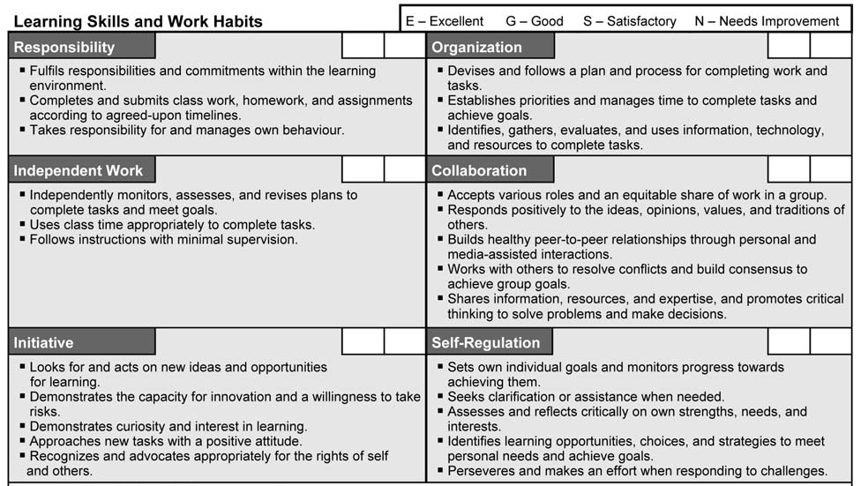
Learning Skills & Work Habits
These learning skills and work habits will be taught, assessed and evaluated throughout the course.

What happens if you’re not learning?


If you need help, please schedule a time to meet with me for extra help. Extra help will be provided before school, during lunch or after school.

You are expected to complete ALL assignments. Should you not meet this expectation, you will be required to attend Study Hall. Not doing is not an option!

ESSENTIAL QUESTION: What kind of person makes an impact?
Unit Outlines
Unit | Key Learnings Focus | How you will demonstrate your learning | Texts, Materials
1. Persuasion | - understanding of texts  - appropriate writing  forms  - oral communication  skills  - analysing media works  - critical thinking | - Speech or debate  - Editorial/opinion paragraph  - review  - news article  - test | 1. Sightlines 10  Early September  News Articles  Speeches  Media analysis
2. Short  Story | - understanding of texts  - appropriate writing  forms  - critical thinking | - comprehension questions  - formal, literary paragraph  - interior monologue | 1. short stories:  Sightlines 10  Early September  Nelson Literacy
3. Novel  Study | - understanding of texts  - appropriate writing  forms  - oral communication  skills  - analysing media works  - critical thinking | - essay skills  - tableaux  - news articles  - reading reflection response(s) | 1. fiction novel:  To Kill A  Mockingbird  2. movie:  To Kill A  Mockingbird
4. Play  Study | - understanding of texts  - appropriate writing  forms  - oral communication  skills  - analysing media works  - critical thinking | - essay skills  - reading strategies log  - round-table discussion/ debate | 1. Shakespeare  play: Romeo  and Juliet or  Midsummer Night’s  Dream or Merchant  of Venice  2. film adaptations for media analysis
5. Research  to make  global  connections | - oral communication  skills  - analysing media works | - PowerPoint presentation | 1. professional  Academic  resources: print  and non-print

NOTE: units may be suppressed, expanded, removed or modified in consideration of students’ learning needs and interests; this is to allow for differentiated learning

